UML DAIGRAM
BATCH-14 ( JOB PORTAL ) 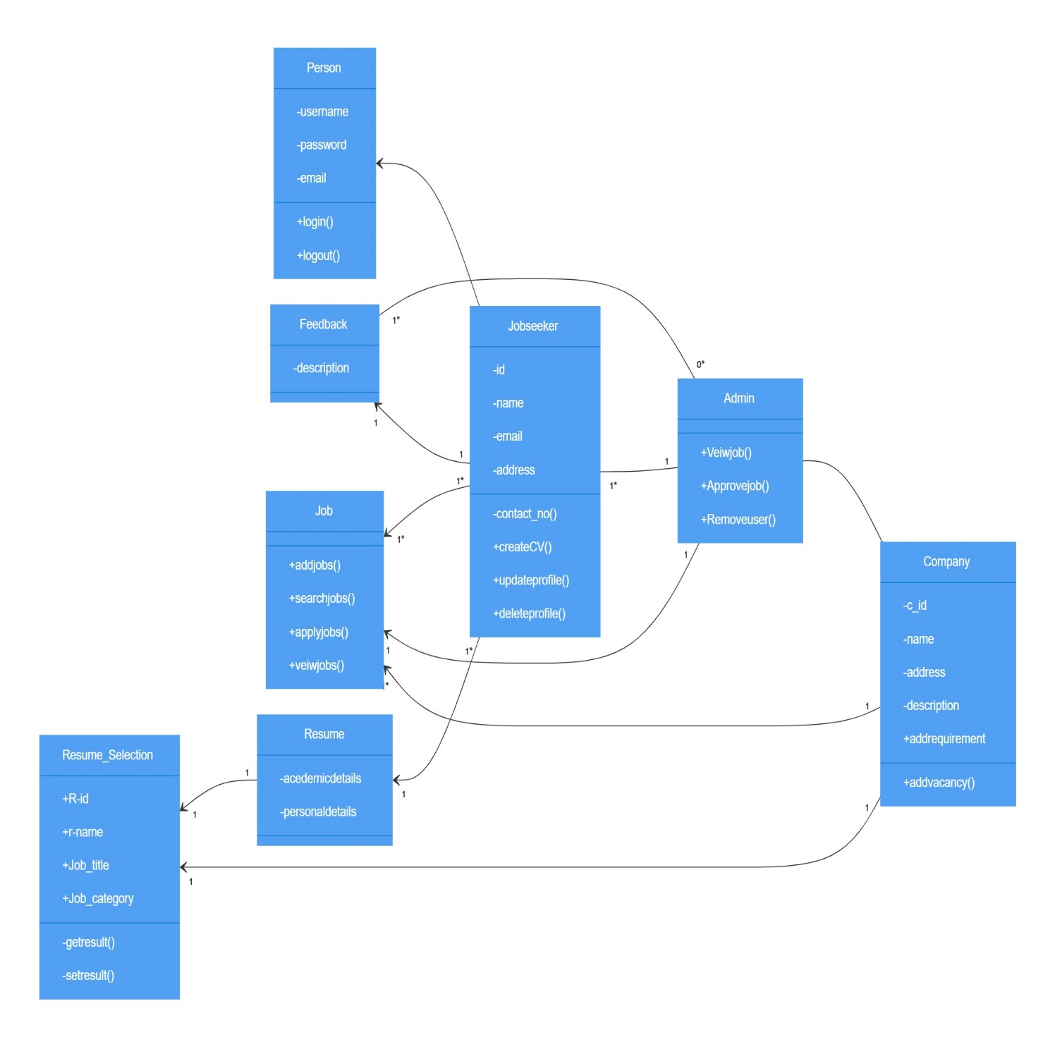

Classes and Attributes:
Person:
Attributes: Username, Password
Methods: login(), logout()
admin :
Methods: ViewJobs(), ApproveJobs(), RemoveUser()
Jobseeker :
Attributes: id, Name, Address, Email_ID, Contact_No
Methods: CreateCV(), UpdateProfile(), DeleteProfile()
company:
Attributes: c_id, name, address, description
Methods: AddVacancy(), AddRequirement()
Feedback:
Attributes: Description
Job:
Methods: AddJobs(), SearchJobs(), ApplyJobs(), ViewJobs()
Resume:
Attributes: academicDetails, PersonalDetails
Relationships:
The admin manages Jobseekers ( admin to Jobseeker with a 1…n ).
Admin approves Feedback ( admin to Feedback with 1 multiplicity).
Jobseekers apply to Jobs (Jobseeker to Job with 1…n multiplicity).
Companies perform Resume Selection (Resume with 1 multiplicity).

